Task 1: Cisco Packet Tracer DHCP Server & Client Setup

Setup & Configuration Steps
- Topology Construction:
- Open Cisco Packet Tracer, place one Server-PT (DHCP Server), one Switch-PT (Catalyst 2960), and two Generic PCs (Client 1 and Client 2).
- Connect all devices using copper straight-through cables to switch ports FastEthernet 0/1 through 0/3.
- Static IP Configuration on the DHCP Server:
- Click the Server $→$ Desktop tab $→$ IP Configuration.
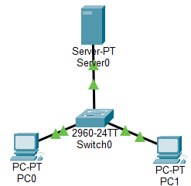
- Assign a static IPv4 address: 192.168.1.254, Subnet Mask: 255.255.255.0, Default Gateway: 192.168.1.1.
- DHCP Service Configuration:
- Go to the Services tab $→$ DHCP.
- Turn Service to ON.
- Set Default Gateway to 192.168.1.1 and DNS Server to 8.8.8.8.
- Configure the Pool Name (e.g., HomePool), starting IP address
(192.168.1.100), and maximum number of users (e.g., 50).
Click Add / Save.
- Client Verification:
- Click Client 1 $→$ Desktop tab $→$ IP Configuration, and select DHCP. Verify that it successfully requests and receives an IP address (e.g., 192.168.1.100).
- Repeat for Client 2 and verify it receives the next available sequential IP address (192.168.1.101).

Task 2: DHCP DORA Process

DHCP uses a four-step process known as DORA.
- Discover: a new client has no IP address, so it broadcasts a DHCPDISCOVER (source 0.0.0.0, destination 255.255.255.255, UDP port 68 to 67) to find any DHCP server.
- Offer: the DHCP server replies with a DHCPOFFER that proposes an unused address from its pool, plus the subnet mask, default gateway, DNS server and lease time.
- Request: the client broadcasts a DHCPREQUEST to accept that offer. It is a broadcast so any other DHCP servers know their offers were declined.
- Acknowledge: the server sends a DHCPACK to confirm the lease. The client then configures its network settings and uses the address until the lease expires.
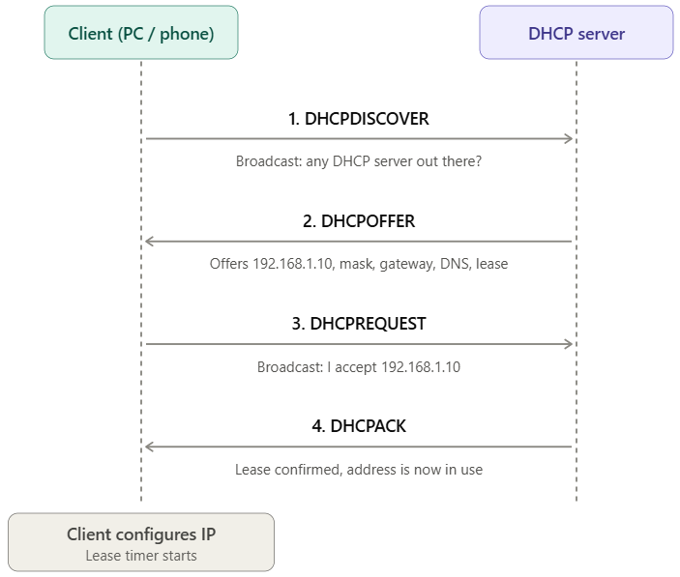

Task 3: Configure a DHCP Pool with Only One IP Address

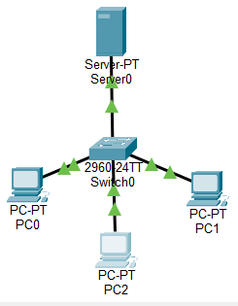
- On the DHCP server, go to Services > DHCP and edit the pool.
- Set Start IP Address to 192.168.1.10 and Maximum Number of Users
to 1. Click Save.
- If the PCs already have addresses, set each to Static, then back to
DHCP to request again.
- On PC0 choose DHCP and wait for it to finish. Then do the same on
PC1.

Explanation of Results
When the pool size is restricted to a single available address, the
first PC successfully acquires that IP address via the DORA process.
However, when the second PC broadcasts its DHCP Discover
request, the server has no remaining unassigned addresses in its
pool, causing the second PC's request to time out and fall back to an
APIPA address (169.254.x.x).

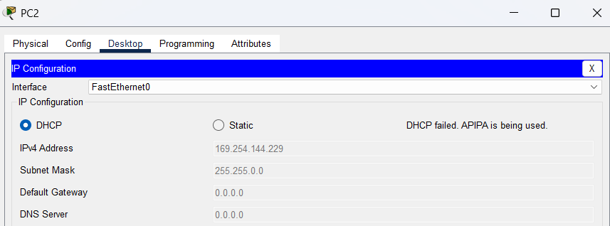

Task 4: Zomato-Style Restaurant Wi-Fi DHCP Simulation

Topology: one Server-PT (DHCP), one 2960 switch, one Access Point-PT, one Laptop-PT and one Smartphone-PT. Connect the server and the access point to the switch with straight-through cables. The Laptop-PT and Smartphone-PT already have Wi-Fi built in. If your trainer wants a generic PC as the phone, power it off, replace the wired module with a wireless one (WMP300N), and power it back on.
Configure:
- Server: set a static IP of 192.168.1.1/24 and turn on Services > DHCP with Default Gateway 192.168.1.1, DNS 8.8.8.8, Start IP 192.168.1.100, Subnet Mask 255.255.255.0, Maximum Users 50. Click Save.
- Access point: open Config > Port 1 and set SSID to Restaurant_WiFi. Optionally set WPA2-PSK with a passphrase.
- Laptop and smartphone: open Config > Wireless0, enter SSID Restaurant_WiFi (and the same passphrase if you set one), and set IP configuration to DHCP.
- Check each device’s IP configuration. Screenshot the result.
Result: Laptop 192.168.1.100 and Smartphone 192.168.1.101, both with gateway 192.168.1.1 and DNS 8.8.8.8.

